Montclair State University

CANDY SHOP

Tufan Baran Demirkol

Muhammad Uzair Javed

Richard Tashjian

CSIT335_0

Project Documentation

The name of the e-commerce business site is “CandyLand Store”. On the website, many customers can log in and buy chocolate, brownies, cotton candy, lollipops, and other sweets online and shipped to their homes. The customer can register an account and login to the website. Their credentials will be stored into the database so once they register their account all they have to do is login next time they visit. Once a customer adds a product to their cart, the product will be added to the database. The customer could also use the search for a specific product of their choice on the website. If the product is not in stock or not located in the database, their search will have no results. If the product is found in the database, then the product will show up on the customers results page. Next time they decide to login, the product will still be in the database, so they will never lose their products they have stored into their cart. The customer can checkout when they are done shopping on the site. The customer can also take a look at their orders, edit their account information, delete their account, or log out of the account. The website consists of 30 products, 4 categories and 4 brands that is sold on the website. If the admin of the website wants to add more products to the site, the admin can go to the admin page and enter his credentials, which will take him to the admin panel. The admin is able to insert, update, and delete products, brands, or categories.

**Data base**

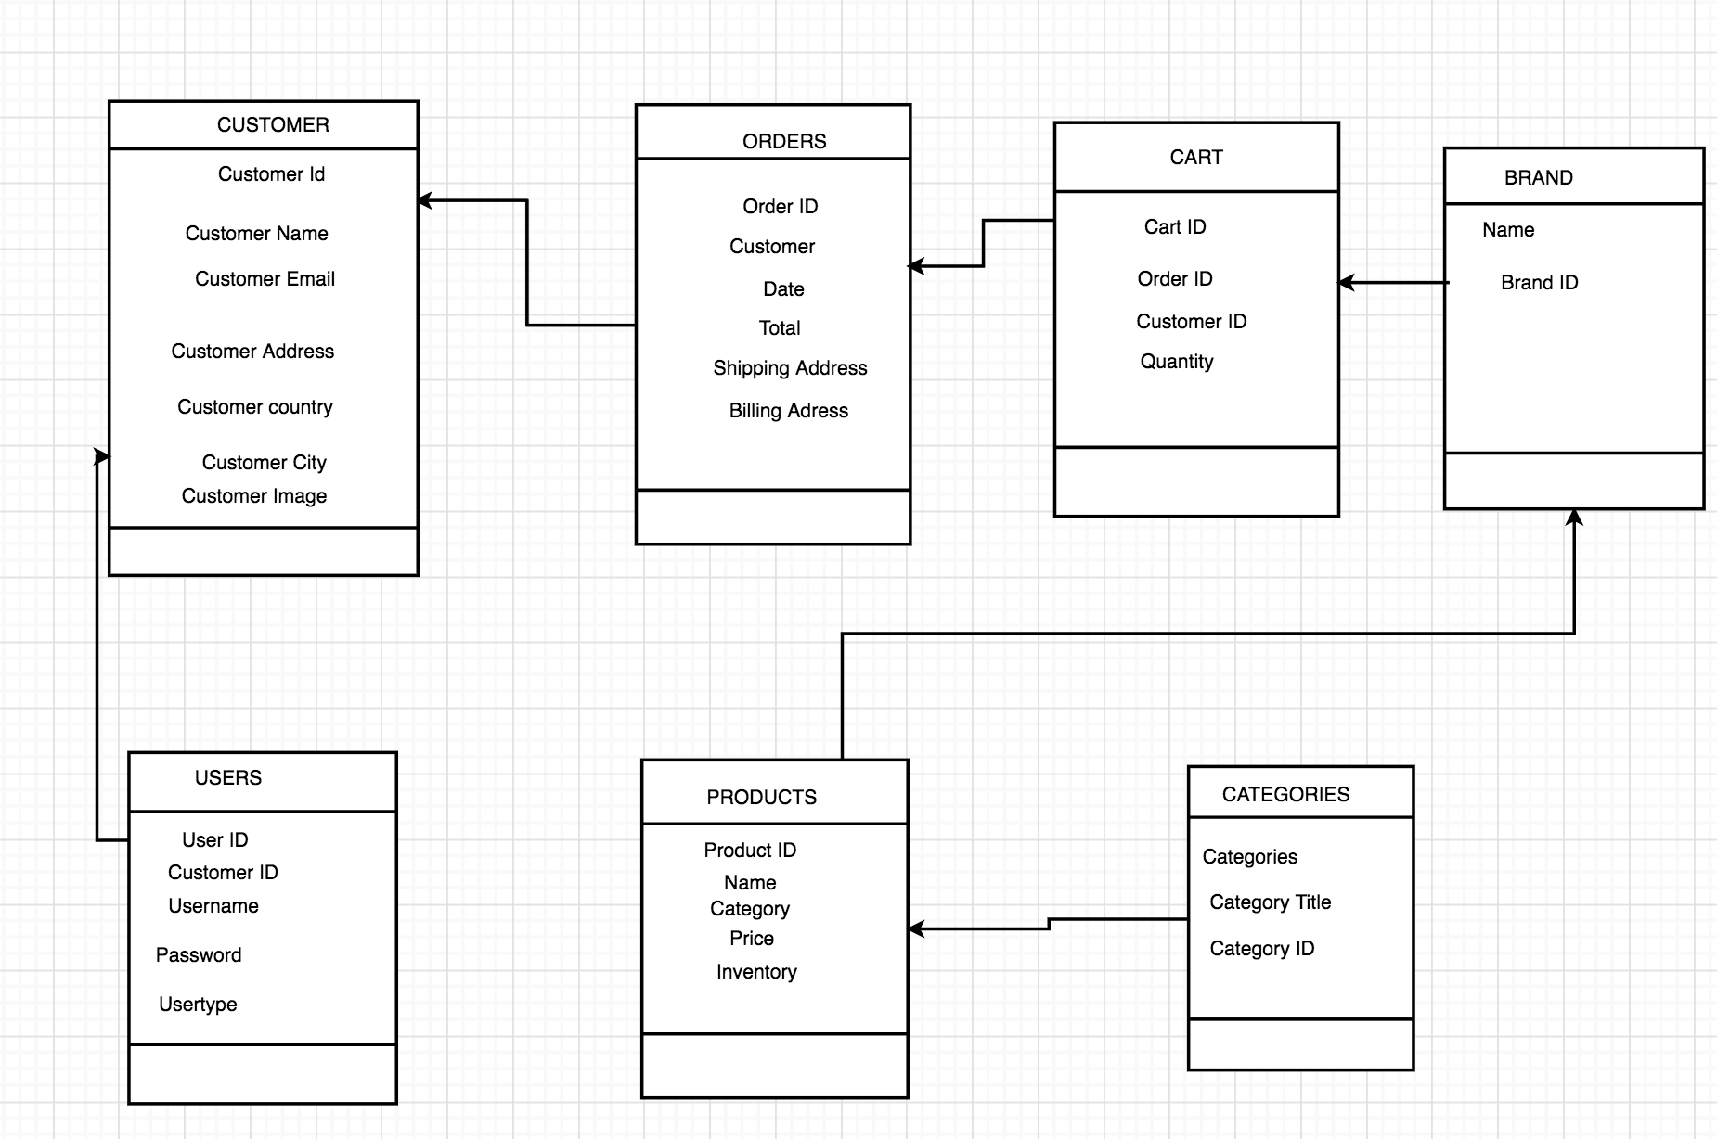

A Customer should be able to browse the products by using the CATEGORIES that has title and id and BRAND has brand id which allows to customer browse around and be able to add a product to their cart. In order for customers to view their order they have to login or create an account in order to to create an account in CUSTOMER where customers have to fill out all the information that include name, email, address and image in order to continue with their order. While the manager can able to view the order status what is placed and how many customers have signed up by using the admin panel and take actions accordingly.

**UserName and Passwords:**

**Customers:**

User name: azair.javed@yahoo.com,

Password: 123

**Database Admins:**

Admin panel Username: javedm1@montclair .edu

Admin Panel Password: 123

Admin Panel Username: demirkolt1@montclair.edu

Admin Panel Password: 123

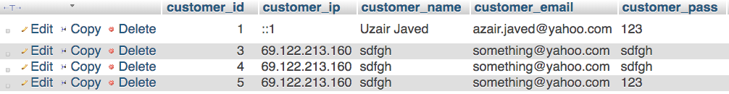

The customer table of the database contains the ID of the customer, the customer IP, the email, and the password of the user. The IP Address is what will define the user and his account. As the user adds a product from our website to their cart, the cart database will then store this IP Address which is connected to the account they made along with a product ID which defines the type of product they added to their cart. Once they re login to their account with the same IP address, the database will be able to recollect the data in the cart table depending on the IP address.

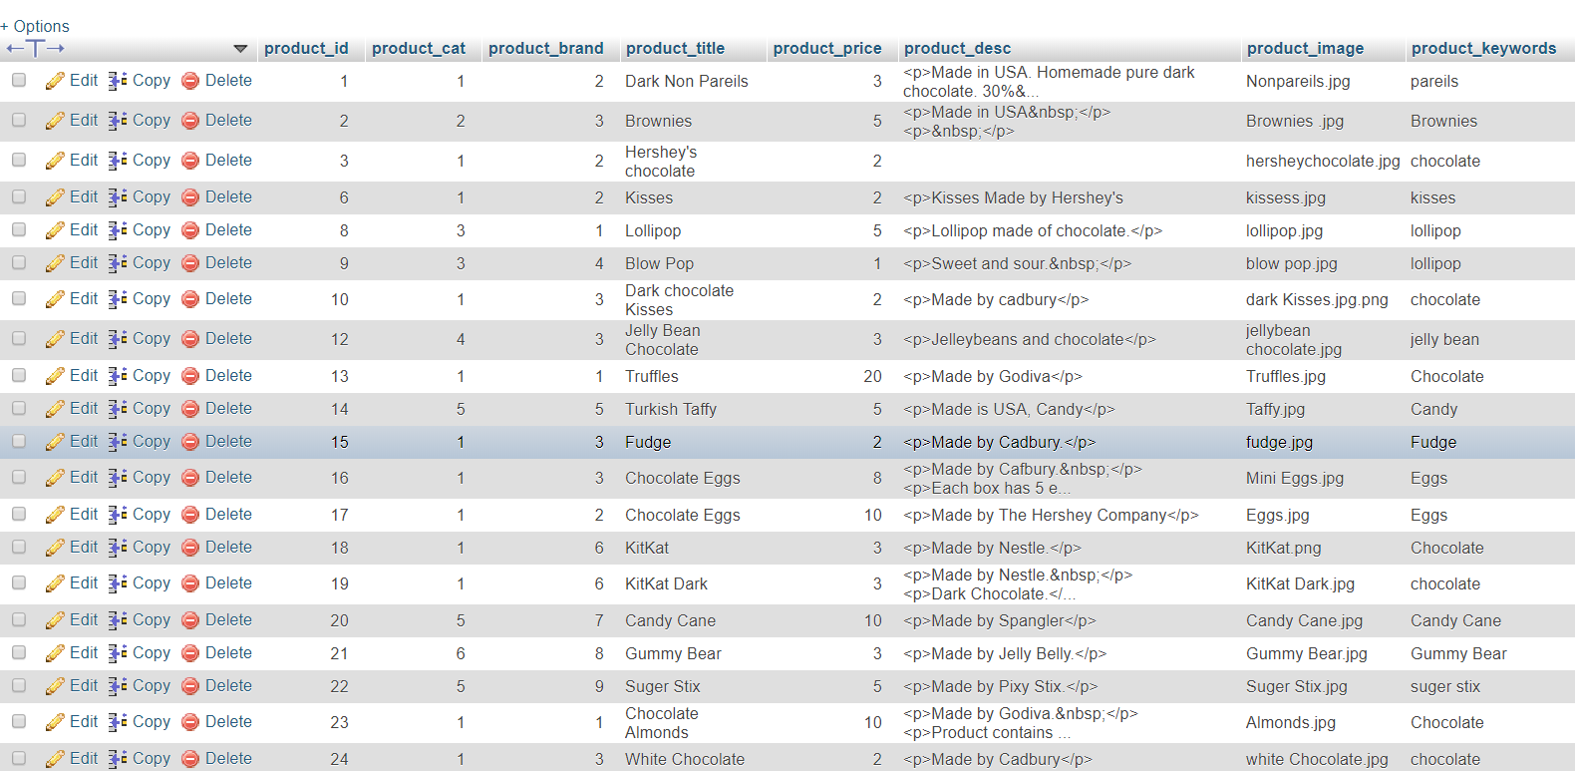

* The website’s menu bar will allow different actions such as changing the page through Cart, Home, All products, My account, Sign Up, Contact Us pages.

**All Products**

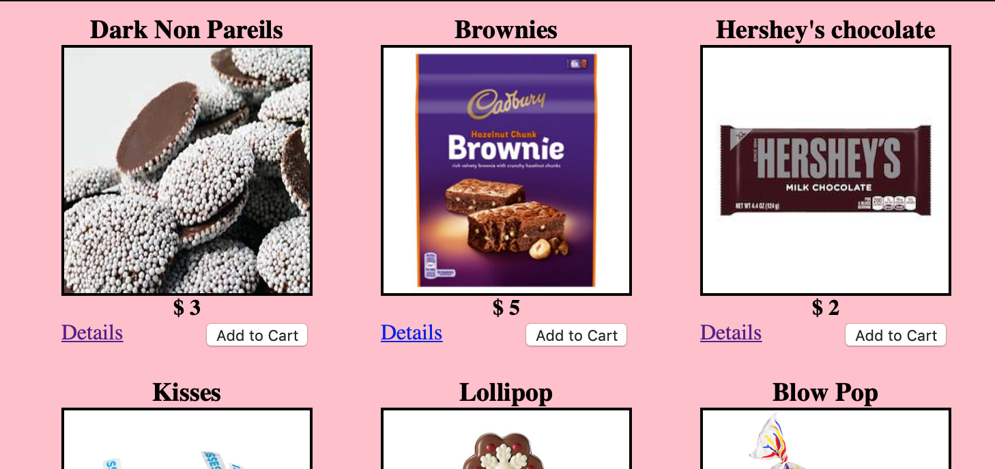

All products has their own unique ID, category, name, price, and inventory. By utilizing the inventory field, an active record of the product’s stock is recorded in the database to prevent users from ordering more than what’s available. To implement this, when a customer is ordering, the customer’s maximum quantity input for a product is set to products’s current inventory.

**Categories**

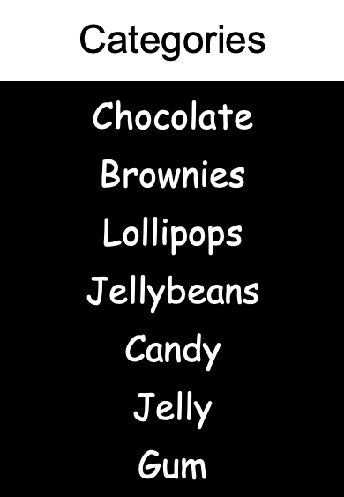

A category table attribute in Home page allows the server to retrieve products in the database by the products’s category. This allow user to select the category they want instead of searching through all products.

**Shopping Cart**

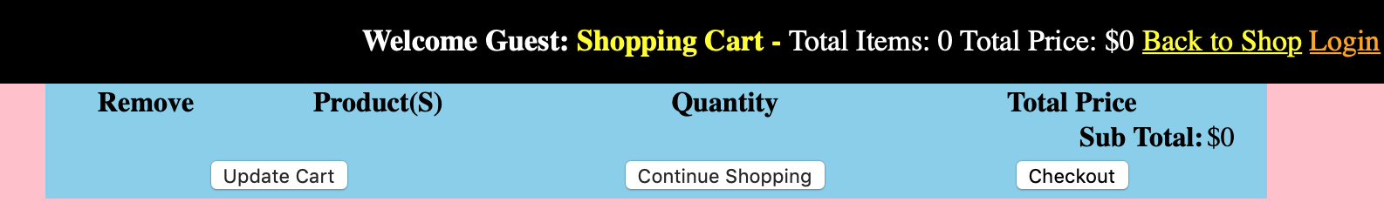

The CART table holds all product IDs, and quantity of the product being ordered. When a customer adds a product to the cart by submitting the form from the Home page, a query is called which directly inserts into the CART table: the product’s ID#, quantity of the product, the customer’s ID, and the order ID. The user can see their product in cart page.

This statement returns from the PRODUCTS table the product data of only the items a specific customer added to cart. Because of the INNER JOIN, the result not only contains product data, but also the customer’s id, order id, and quantity of the product. As a result, each customer querying the CART table will receive a unique cart listing items that only that specific customer chose.

Submitting the cart form redirects to the checkout form which will obtain additional information such as recipient’s name, shipping address, and billing address.

**Log in/ Sign up**

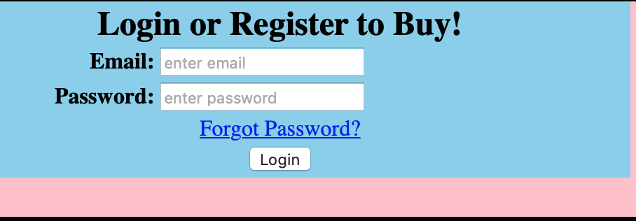

The user can sign up to the website with their information such as Name, Email, Address, Image. When user logs in to the website they can view their cart anytime they want. The data will be saved. The user can view their information and change it.

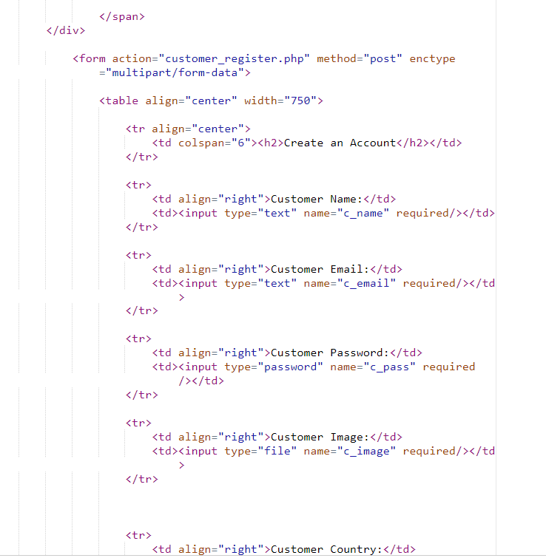

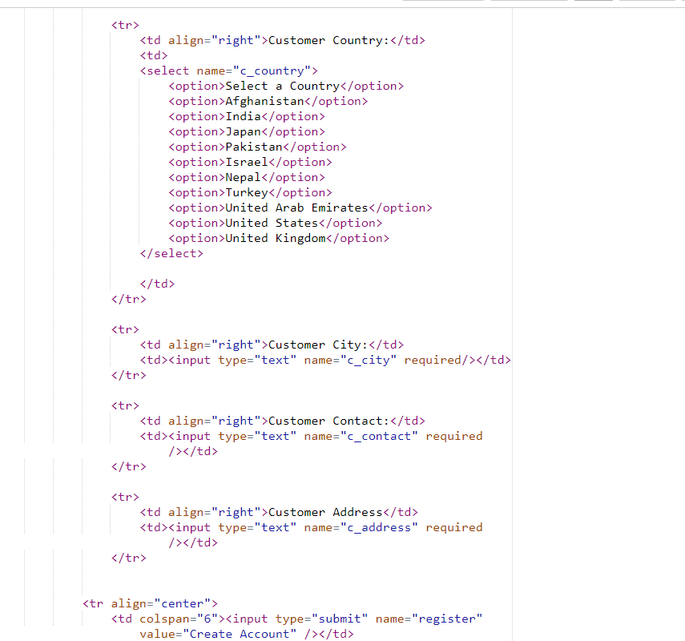

The codes above are from the customer registration page. Each Line such as the customer image, password, user, country, etc… is formatted into a table. The user enters in their information as well as pick an image that they want to use as their profile pic. Once the user is done, they click the enter button, which will submit their information and place them into the database.

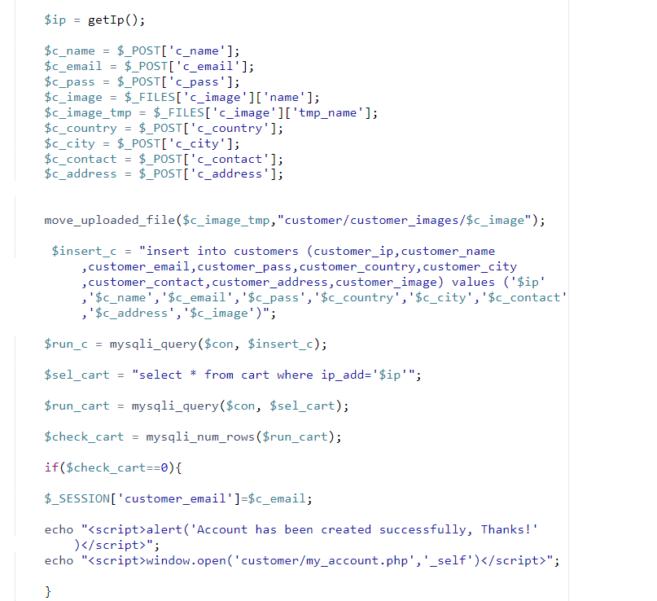

The code above is also from the customer registration page. It first grabs the customer IP, Then variables are created to store the information that was given by the user. Next the image that was uploaded is stored into a certain file called “images” so each time the user logs in, their profile picture is always there. The variable $insert_c will be the variable that will hold the information that will insert the information the user gave into the database. We used “INSERT INTO” command and the customers table, along with each of the names of the attributes in the database. After that, we then place the values which are the user’s information in the correct form so that the information is stored into the right attribute. We then see if the cart can select an account from that given IP address with the $sel_cart variable and run the cart with the database and the variable to check. We then check the cart and see if there is any IP ADDRESS with an existing account. If the variable returns 0, then the account can be created successfully, and now the account is stored into the customers table.

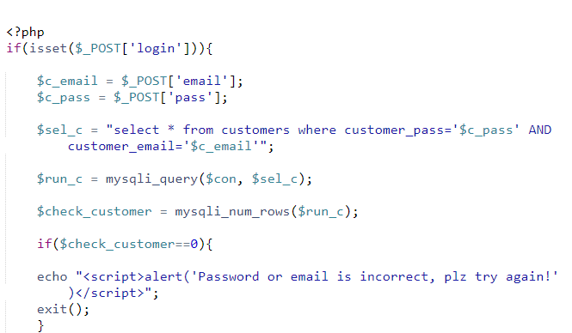

The code checks to see whether or not the entered input by the user has the correct login credentials that they have made in the customer registration. If their login is not in the database under customers it will print out the message below and exit the website back to the home page. When the user enters the correct credentials that they have in our database then they will proceed to the My_Account Page which will have access to their orders and account information. The Variable $sel_c will have the information that is grabbed from the database using “SELECT FROM WHERE” command. It is selecting all information from the customers table in the database and extracting every username and password to see if the user has entered a valid account on the website. If there are no rows in the database, the database will return 0 to the $check_customer variable. The code then checks to see if the value stored in the $check_customer is 0. If the condition is satisfied, then the user’s credentials is invalid. Otherwise, the login will go through.

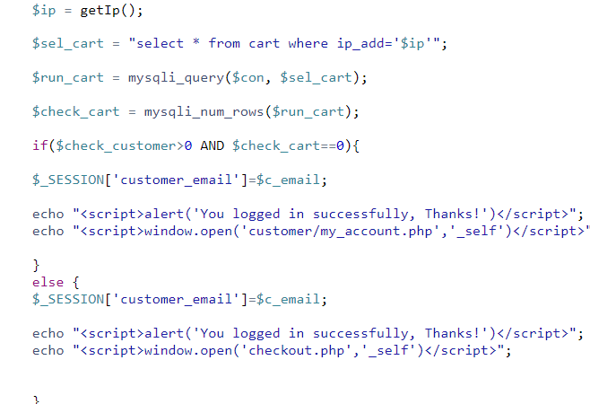

We use the get IP function that we have to grab the user's ID which will help us detect what products the user has added to their cart when they login to the website again. We use the SELECT FROM WHERE command to select all information in the cart under the attribute id_add. We then use the variable $check_cart to check the number of rows. If the customer is greater than 0, meaning there is a user in the database and that user has a cart which is equal to 0, meaning nothing in the cart, then the user will login and be redirected to the myaccount.php page. If the user’s cart is greater than 0, then the user will login and be redirected to the checkout.php page.

**Security Implementation**

The user should be prompted to login before viewing any data. Upon logging in, the session’s status is set and will remain set until timed out or logging-out. The status check is included in the menu bar, which is used for all pages on the website. Therefore, if at any time the status times out or is unset, the user will be prompted to log in again.

**Conclusion**

What would we do if we had more time?

We would fix up the style of the website better and make more pages such As a Contact Me page which will include the client to add information about themselves to help the moderators of the website

Identify the client that is asking for help on our website and The issue at hand, which will be submitted and sent to the Moderator, and an About Me page to allow users to give a better understanding

Of what our business is and why our website is a better choice for buying Candy than other websites out there. This would give ourselves more practice in creating an ecommerce website.

**Citation**

All images were found from the following sites:

“GODIVA Chocolatier Chocolate” *GODIVA Chocolates | Gourmet Chocolates, Gift Baskets and Truffles*, [www.godiva.com/on/demandware.store/Sites-Godiva-Site/en_US/Default-Start?mrkgcl=1230&mrkgadid=3316540954&gcid=PS%7CMKL%7CKCT%7CECO%7CGOO%7CNA%7CSEM%7CEVERGREEN%7CNA%7CTXT%7CUS%7Cnone&adpos=1t1&creative=333101567913&device=c&matchtype=e&network=g&gclid=CjwKCAjwwtTmBRBqEiwA-b6c_4BA7lHLEArhpRpVm7DzNfilpmqdoIexNuCPEe-7trk1NMBXyKd0dRoCMt0QAvD_BwE](http://www.godiva.com/on/demandware.store/Sites-Godiva-Site/en_US/Default-Start?mrkgcl=1230&mrkgadid=3316540954&gcid=PS%7CMKL%7CKCT%7CECO%7CGOO%7CNA%7CSEM%7CEVERGREEN%7CNA%7CTXT%7CUS%7Cnone&adpos=1t1&creative=333101567913&device=c&matchtype=e&network=g&gclid=CjwKCAjwwtTmBRBqEiwA-b6c_4BA7lHLEArhpRpVm7DzNfilpmqdoIexNuCPEe-7trk1NMBXyKd0dRoCMt0QAvD_BwE).

“HERSHEY'S” , [www.hersheysstore.com/kisses/c/hersheys@ourbrands@kisses](http://www.hersheysstore.com/kisses/c/hersheys@ourbrands@kisses).

“KITKAT.” *KITKAT*, [www.kitkat.com](http://www.kitkat.com)

“Jelly Beans.” *Sugar-Free Jelly Beans and Gummi Bears*, [www.jellybelly.com/sugar-free-candy/c/338?gclid=CjwKCAjwwtTmBRBqEiwA-b6c_8-T-wLLMpDjjk0Ef0MRZQb3URQUrTZDlO69k8VSASuVcD8eHgDOEBoCIRUQAvD_BwE](http://www.jellybelly.com/sugar-free-candy/c/338?gclid=CjwKCAjwwtTmBRBqEiwA-b6c_8-T-wLLMpDjjk0Ef0MRZQb3URQUrTZDlO69k8VSASuVcD8eHgDOEBoCIRUQAvD_BwE).

“Orbit® Gum.” *Orbit® Gum*, www.orbitgum.com/.

“Cadbury Chocolate.” *Cadbury*, [www.cadbury.co.uk/](http://www.cadbury.co.uk/).

Denise, et al. “Chocolate Nonpareils | Chocolate Nonpareils.” *Nuts.com*, 20 July 2017, nuts.com/chocolatessweets/premium-chocolates/nonpareils/dark-chocolate.html.

<https://warheads.com>

“Order Premium Bulk Nuts, Seeds, Dried Fruit & More.” *Sincerely Nuts*, sincerelynuts.com/.

<https://www.nestleusa.com>

<https://www.spanglercandy.com/?gclid=EAIaIQobChMIo6Deq9qX4gIVw56zCh0c3AcDEAAYASAAEgJ9yPD_BwE>

<http://www.bonomoturkishtaffy.com>

<https://www.candywarehouse.com/charms-cherry-blow-pops-48-piece-box/>